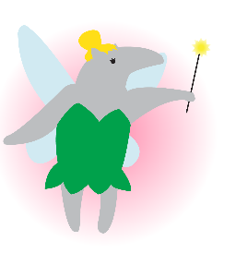

Presenting…  
**Circle K International**

**at UC Irvine**

2012 Fall Quarter, Wk 3

Tuesday, October 16, 2012

www.ucicirclek.org

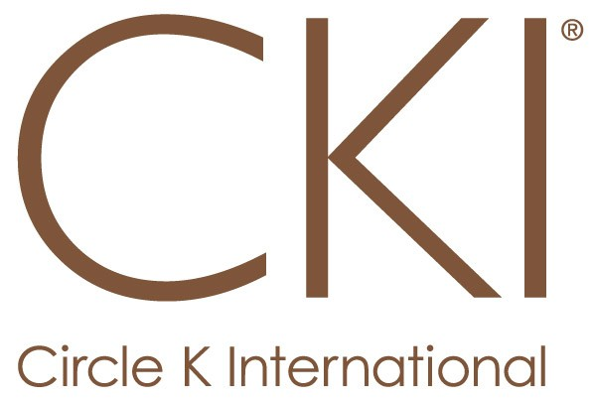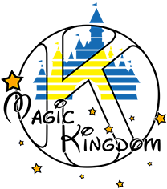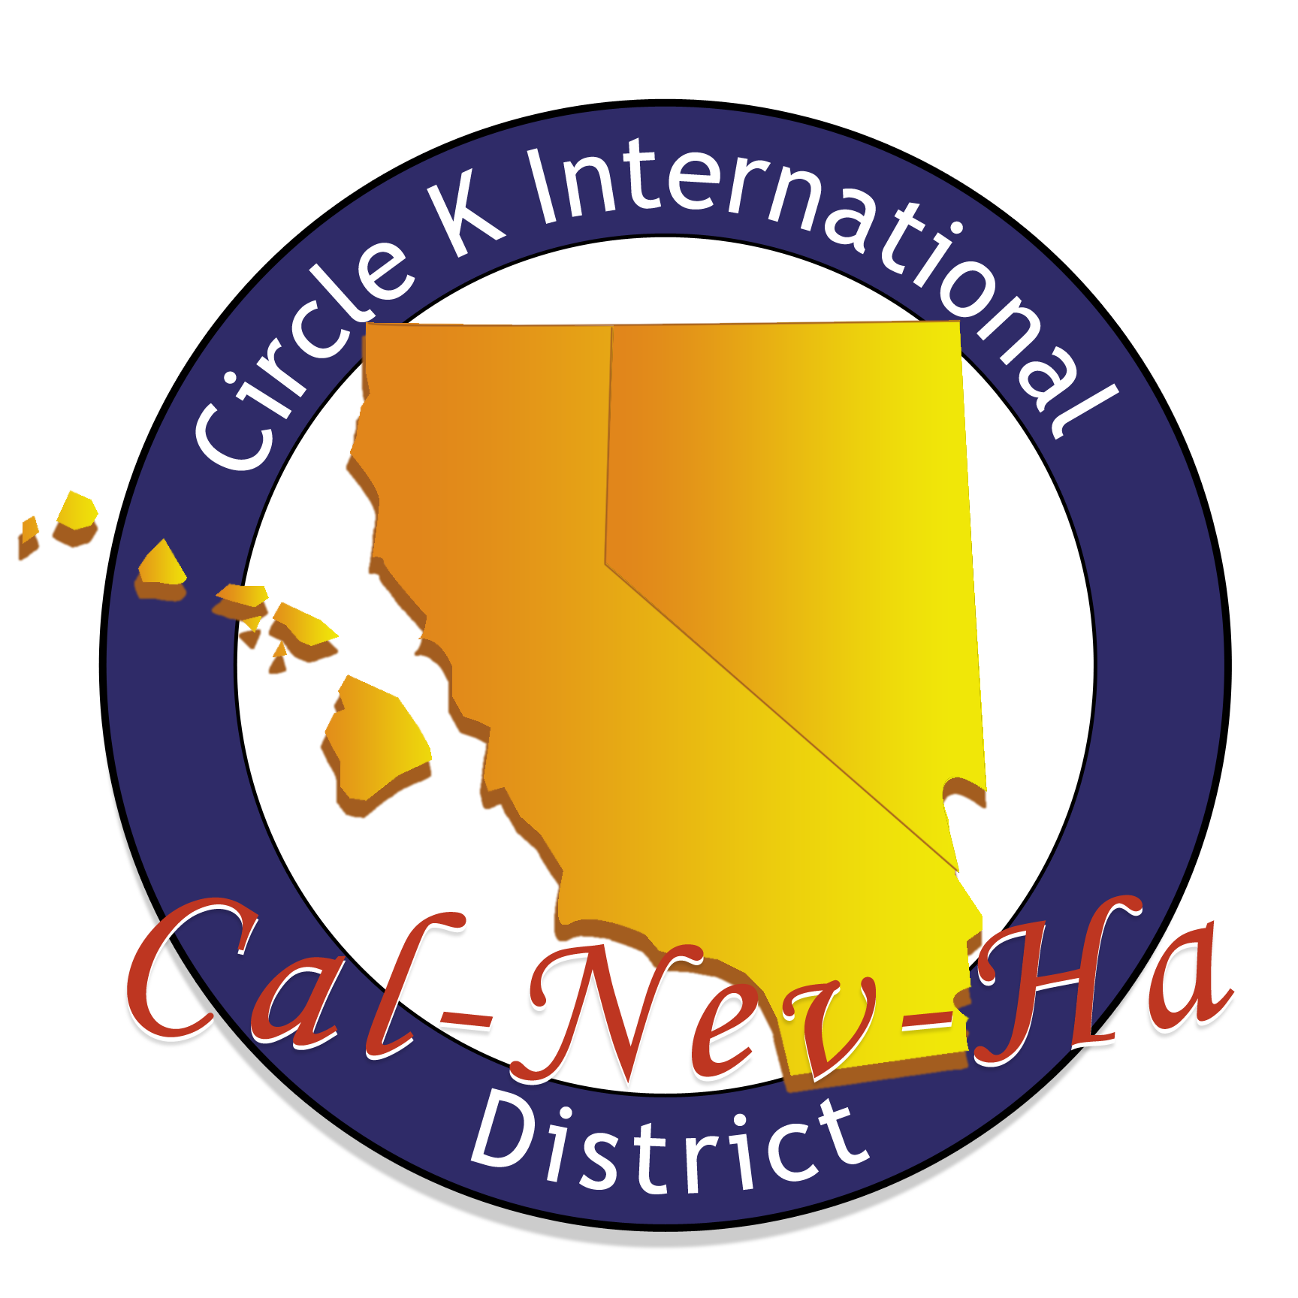

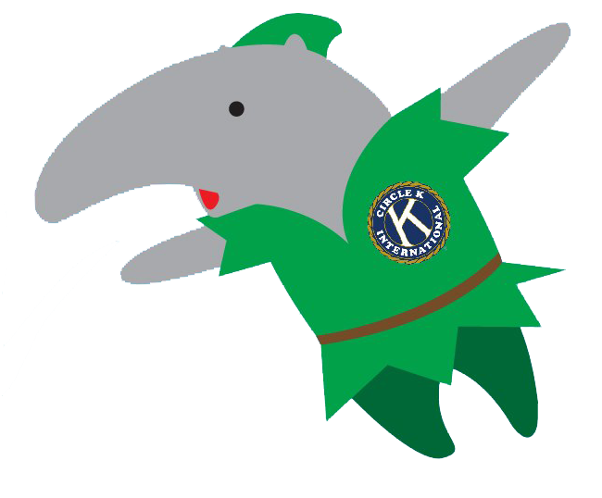

## October 2012

|  |  |  |  |  |  |  |  |
| --- | --- | --- | --- | --- | --- | --- | --- |
|  | TUES. Oct. 16 | WED. Oct. 17 | THURS. Oct 18 | FRI. Oct 19 | SAT. Oct. 20 | SUN. Oct 21 | MON. Oct. 22 |
| SERVICE |  | -**Working Wardrobe** @2:50-5pm | -**Book Doctor** @ 3:30-5:30pm  -**Blood Drive** @  12 – 6 PM @ CSL  **-Little Dresses for Africa** @  7 - 9 PM - SSL 240 | -**Hemopet** @ 8:30-11am  -**TV Taping Fundraiser** @  2 – 10 pm  -  **Quilt Project** @  8 – 10 pm | - **Color Dash to End Stroke**  @  6:30 AM – 1 PM |  | -**Think Together** @  2:50 PM – 5:00 PM  - **Apron Project with Single Service** @  7 PM – 9 PM |
| LEADERSHIP | -**Irvine Kiwanis** @ 7-9am  -**Whittier CKI Mtg** @ 3:15pm  -**OCC CKI Mtg** @ 4pm  -**UCI CKI Mtg @** 6pm | -**DISTRICT:**  **FTC** FEES DUE: $100  -**DISTRICT: CKI SOUTH** FEES DUE: $6  -**SAC CKI Mtg** @ 3:30pm  -**CHAIRS/CERFS Workshop:**  @ 7-8pm in SSL 145 | **-CDM Kiwanis Takeover** @ 11:30am-1:50pm  -**FV Kiwanis Mtg** @ 11:45am-1:30pm  -**IVC CKI Mtg** @ 2:30pm  -**Saddleback CKI Mtg** @ 2:50pm  -**CSUF CKI Mtg** @ 5pm  -**Tech Mtg** @6pm in HH 224 | -**Lake Forest Kiwanis Mtg** @ 6:40-9am |  | **-CKI South** @  7:30 AM – 5 PM  **-MRP Committee Mtg** @ 5-6pm in Emerald Bay DE  -**Board Meeting** @6pm in Newport Beach A | **-Saddleback Kiwanis** **Mtg** @ 11am-2:15pm  -**Fundraising Committee Mtg**  @ 5-6pm in SSL 228  **-Single/Service Committee Mtg**  @ 6-7pm in SSL 228 |
| FELLOWSHIP | **-Koba Eat-for Service** @ 8pm | **-Coffee Time w/ Sarina** @ 11-1pm |  |  |  | -**Volleyball Social** @ 3-4pm in Arc |  |

**UPCOMING EVENTS**

**BLOOD DRIVE BOOTHING:** Wednesday 10/17 || 11-2PM on Ring Road

**DISTRICT EVENTS**: CKI SOUTH – 10/21 || FALL TRAINING CONFERENCE (FTC) – 11/2-11/4

**REMINDERS**

**Gen. Mtg Locations**

1. **Call to Order – Sarina Saldana, President**
2. **Introduction of Guests – Sarina Saldana, President**
3. **Upcoming Service Events – Amy Hoang**
4. **Bulletin – Adrian Francisco**
5. **Fundraising – Connie Phan & Ryan Leung**
6. **K-Family – John Delshadi & Samia Chowdhury**
7. **MD&E – Liz Ly**
8. **Shoutout Box – Adrian Franciso**
9. **MRP – Tanya Luu**
10. **PR – Charmaine Deomampo & Nathan Magoto**
11. **Scrapbook – Kevin Lam**
12. **Single Service – Michelle Ha & Samantha Ho**
13. **Spirit/Social – Lany Dao & Sam Barke**
14. **Technology – Brian Chew**
15. **VPA – Mayra Escobar**
16. **Treasurer – Elmore Villaruel**
17. **Secretary – Karen Truong**
18. **President – Sarina Saldana**
19. **Meeting Adjourned – Sarina Saldana, President**

Week 4: RH 104

Week 5 & 6: Doheny Beach A  
Week 7: Pacific Ballroom C

Week 8: Pacific Ballroom D

Week 9: RH 104

**Website:** www.ucicirclek.org  
**Facebook:** http://www.facebook.com/groups/242970149059638/  
**Tumblr:** http://ucicki.tumblr.com/  
**Flickr:** http://www.flickr.com/photos/ucicirclek  
**Newsletter:** http://issuu.com/adrianfrancisco

**Agenda**

**GET CONNECTED**

* **Member Application?** Ask a board member or download one from our website: [www.ucicirclek.org](http://www.ucicirclek.org)
* **REGISTRATION FOR CKI SOUTH (On-site $8) + FTC ($100) DUE OCT. 17!!!**
* **Drop off Dues/App.** during Gen. Mtg, to any board member,
* Click on an event you like on the calendar and **sign up online to attend**: <http://clubs.uci.edu/circlek/SSB_calendar.php>
* **Need a ride to an event?!?!** Meet at the flagpoles for ALL events!
* **Want to chair an event?** Add your name and number on our Chair Doc: <https://docs.google.com/spreadsheet/ccc?key=0AnKaL6lqusFSdFhvbWNYNklING42UEpNSHVCTk9CZ1E&authkey=CICZjZED&authkey=CICZjZED>
* **Want to Submit an Article for “The Second Star?”** Contact our Bulletin Chair, Adrian Francisco!
* **Blood Drive: Please make an appointment @**<https://www.healthcare.uci.edu/blooddrive/SchEntry.aspx?id=Campus>

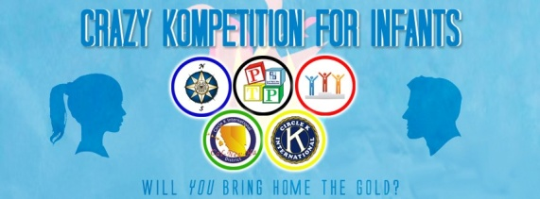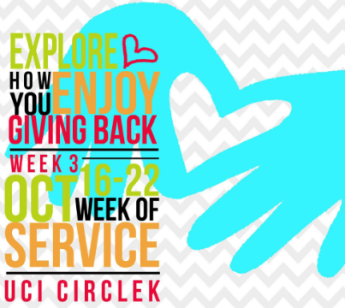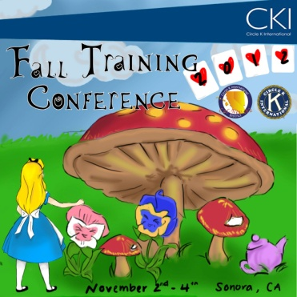

**UPCOMING EVENTS**

**BLOOD DRIVE BOOTHING:** Wednesday 10/17 || 11-2PM on Ring Road

**DISTRICT EVENTS**: CKI SOUTH – 10/21 || FALL TRAINING CONFERENCE (FTC) – 11/2-11/4